Assignment AWS Essentials September 2021

Assignment 1,

Working with IAM

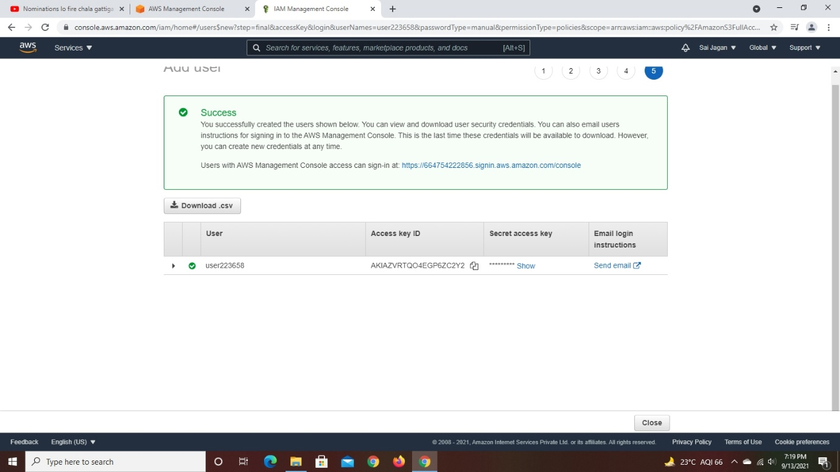1.Create an IAM User

2.Attached AWS Managed policy(S3 Full Access)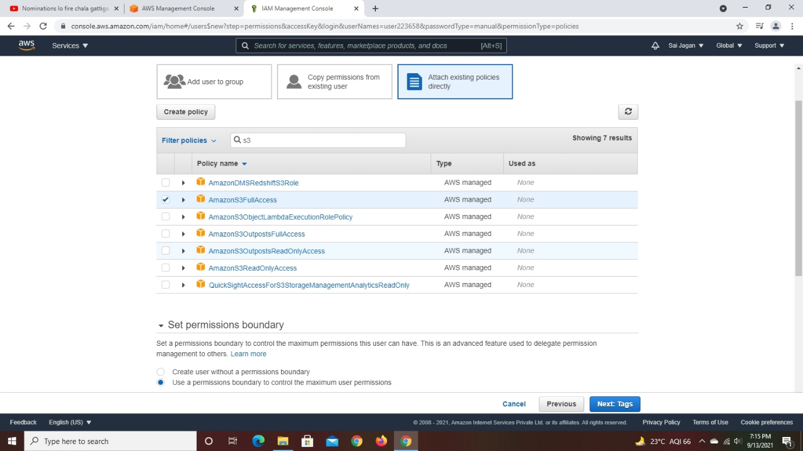

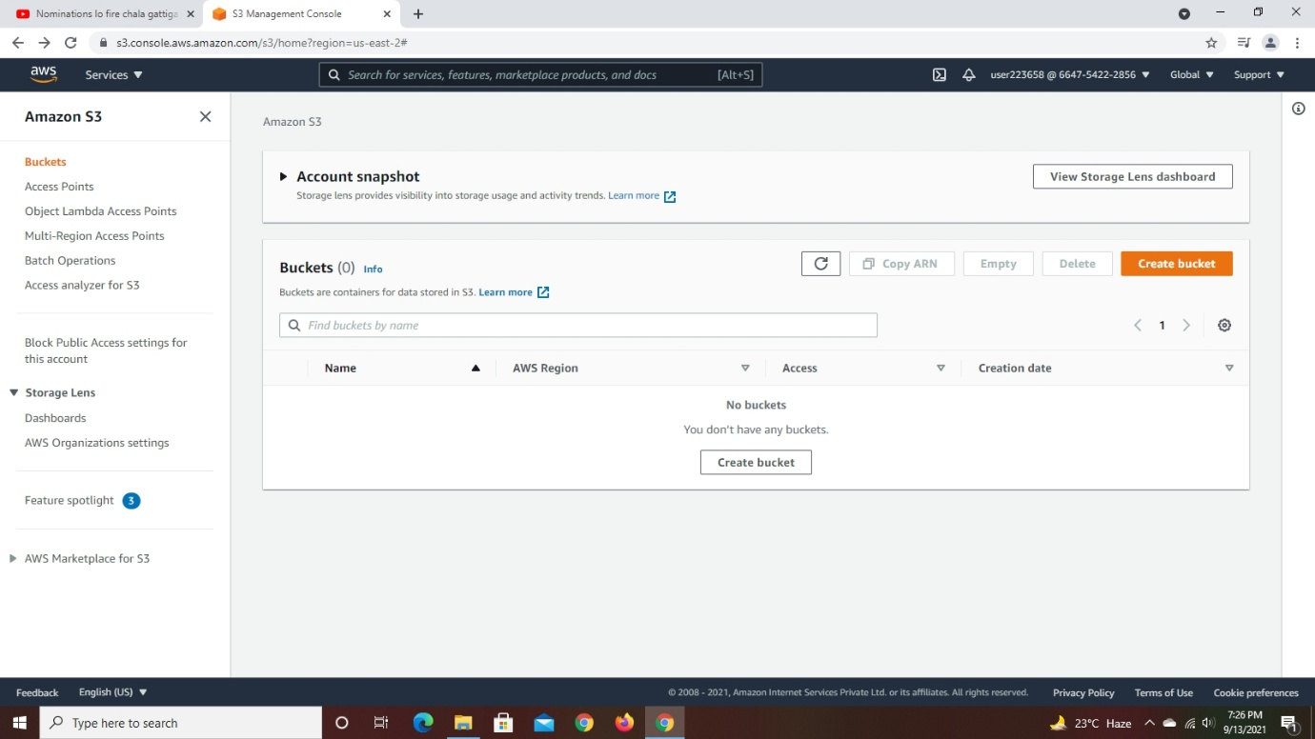3.Login an IAM User to show the policy applied

(i) S3 full access

(ii) EC2

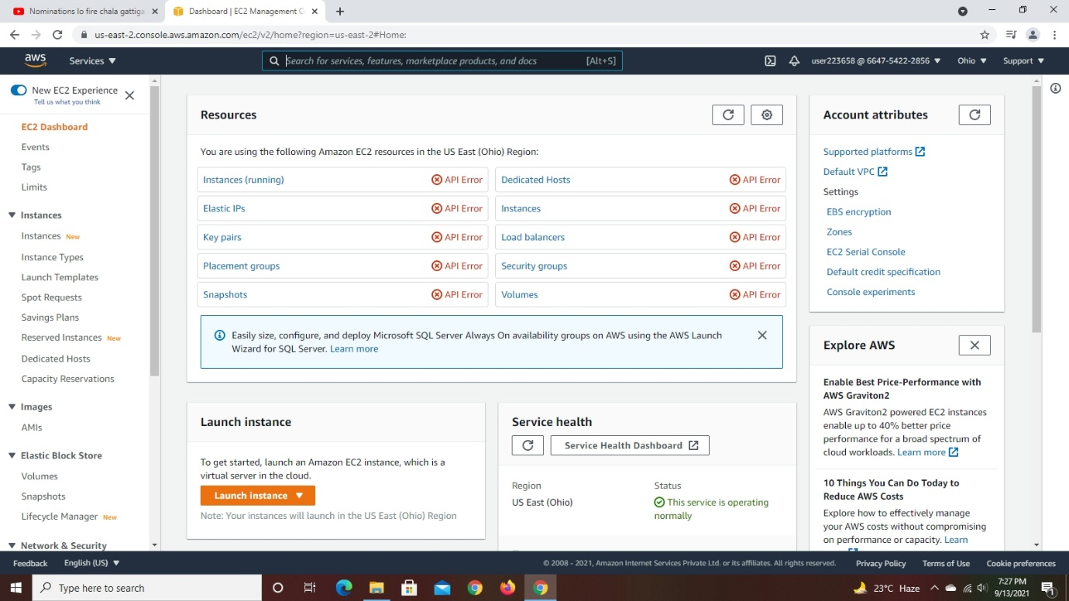

(iii) IAM

